WEEK-07-SEARCHING ALOGORITHMS-LINEAR AND BIANRY

WEEK-07-01-PRACTICE SESSION-CODING

Reg no:241801289

Name :Tamilselvan.k

Q1

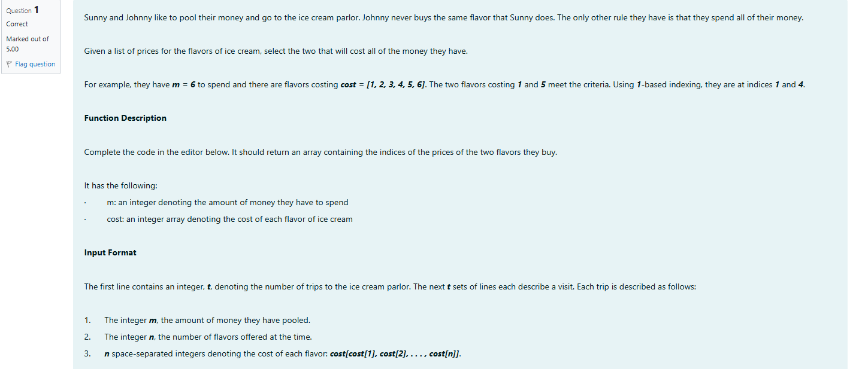

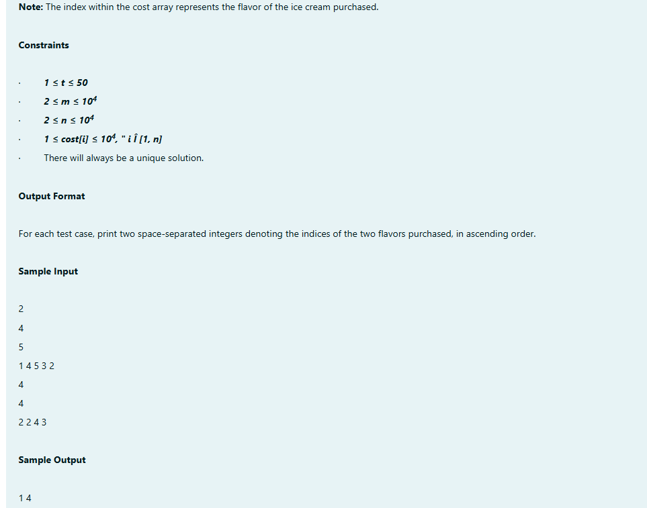

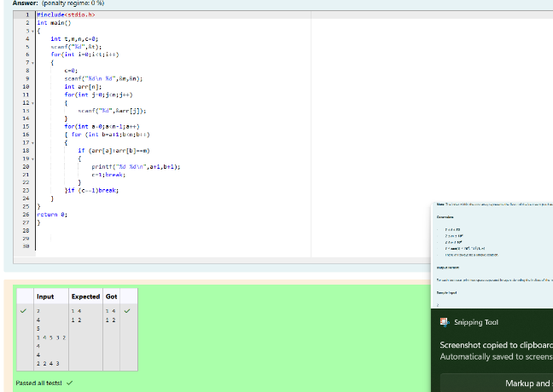

WEEK-07-01-PRACTICE SESSION-CODING

Reg no:241801289

Name :Tamilselvan.k

Q2

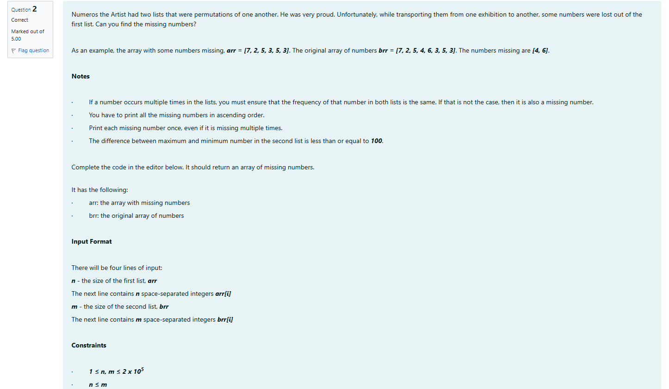

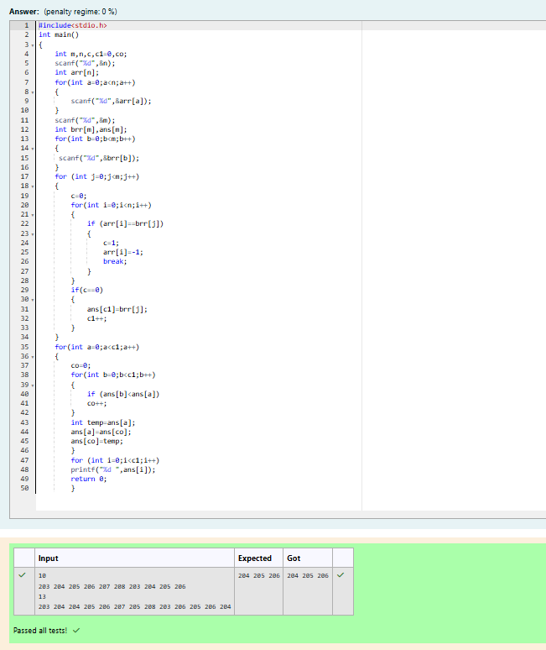

WEEK-07-01-PRACTICE SESSION-CODING

Reg no:241801289

Name :Tamilselvan.k

Q3

